System Level Test: This tests the software to ensure it is working properly before being released and this means testing the software as a whole. This type of testing is also considered as black box type testing. Independent tester usually performs this type of testing on software. While studying this, there is actually over 50 different types of testing but the main testing focuses on these in the diagram.

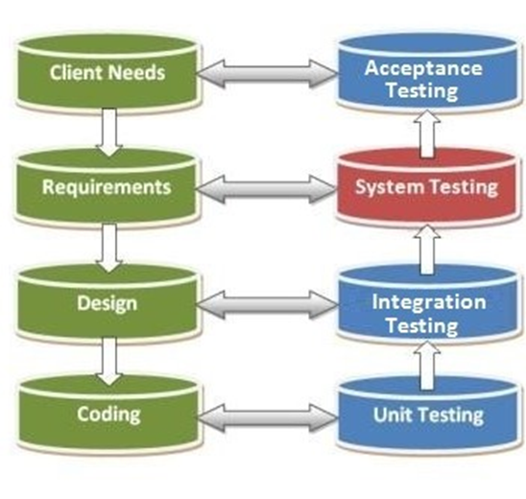

Simple Examples:

ATM - Verify that a user is asked for their pin number before displaying any sensitive options/information

Calculator – Testing will ensure all functions work and user inputs and outputs are correct